Air sampling for a better world
An inniative by becoh & sysmex
WHWB is a non-profit organization that tackles occupational health and hygiene issues in the developing world. WHWB intends to engage volunteers in improving workplace health in those regions of the world with underserved worker populations. Their focus is to provide workers and employers with technical assistance, training and skills development to help them develop capacity and infrastructure to manage and improve the health conditions in their workplaces. They also hope to help NGOs in developing countries to integrate occupational health into their projects.
About the project
BeCOH joined forces with us, Sysmex. Together we started the 'Air sampling for a better world' project. Worldwide there is a lot of interest in the industrial hygiene projects from WHWB. As a result, there is shortage of air sampling pumps. Our goal is to collect as many older air sampling pumps as possible in order to support these valuable WHWB initiatives around the world.
How can you participate?
We attempt to collect as many 'old' pumps (GilAir-3 and GilAir-5 type) as possible. So, if you have stored some pumps somewhere in a dusty box or you’re still using them but it’s time to replace? If so, please give them a second life by donating them for our project.
If you want to donate your pumps, please scroll down and complete the form.
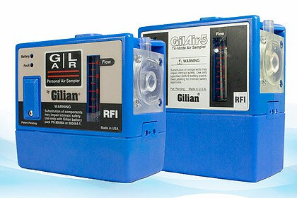
What will we do with your pumps?
Once you have informed us that you want to donate air sampling pumps we will proceed with the following process:
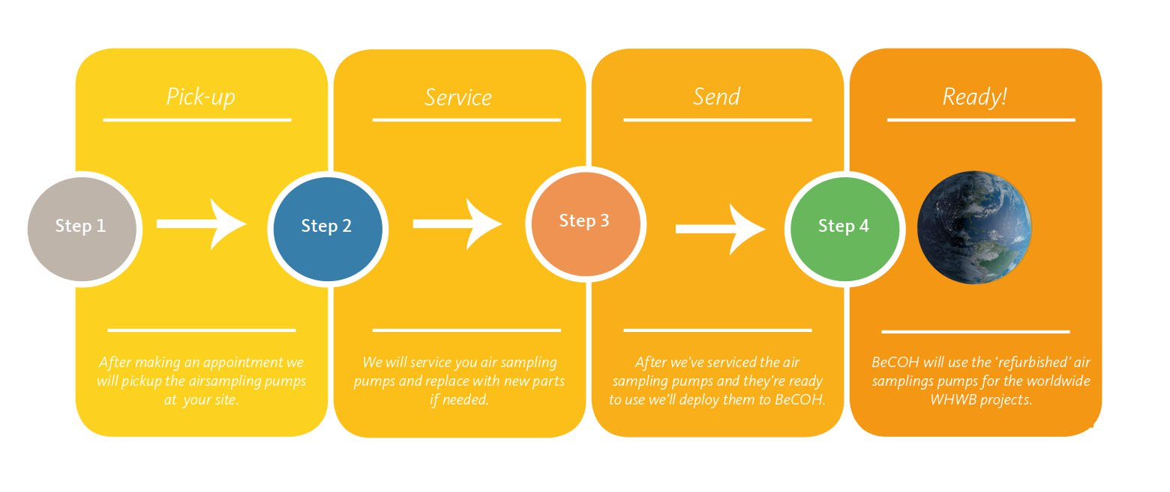
Our goal
We intend to collect as many pumps as possible, but it is better to set a collective goal. So we did! We aim at collecting 60 air sampling pumps in a period of 6 months.
More information: https://content.sysmex.nl/whwb

